**Program:**

**Document Structure Tags**

<!DOCTYPE html>

<html>

<head>

<title>This is title of web page</title>

</head>

<body>

<h1>web programming.<br></h1>

<p>this is practical number 1.</p>

</body>

</html>

Output:

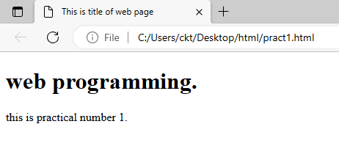

Program:

<!DOCTYPE html>

<html>

<head>

<title>This is title of web page</title>

</head>

<body>

<p><b>Bold</b> Text element.</p>

<p><strong>strong</strong> Text element.</p>

<p><i>Italic</i> Text element.</p>

<p><emp>emphasized</emp> Text element.</p>

<p><u>Undrline</u> Text element.</p>

<p><ins>Undrline</ins> Text element.</p>

<p><mark>Mark</mark> Text element.</p>

<p><small>small</small> Text element.</p>

<p><del>deleted text</del> Text element.</p>

<p>This <sub>subcript</sub> Text element.</p>

<p>This <sup>supercript</sup> Text element.</p>

</body>

</html>

**Output:**

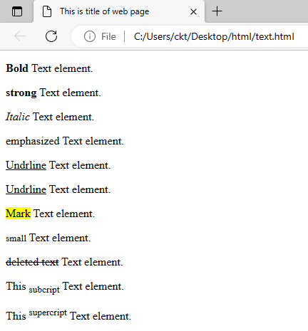

**Program:**

<!DOCtYPE html>

<head>

<title>HTML_unorderedlist</title>

</head>

<body>

<h1>Unordered list</h1>

<ul>

<li>Web programming</li>

<li>Python</li>

<li>C++</li>

<li>Operating system</li>

<li>Toc</li>

</ul>

<h1>Ordered list</h1>

<ul>

<li>Web programming</li>

<li>Python</li>

<li>C++</li>

<li>Operating system</li>

<li>Toc</li>

</ul>

<body>

**Output:**

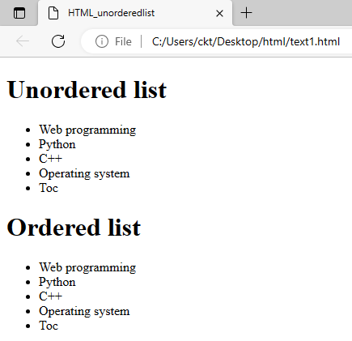

**Program:**

<!DOCtYPE html>

<html>

<head>

<title>Displyaing img</title>

</head>

<body>

<p>Using Image in Webpage.</p>

<img src="flower.png" alt="Flower">

<body>

<html>

Output:

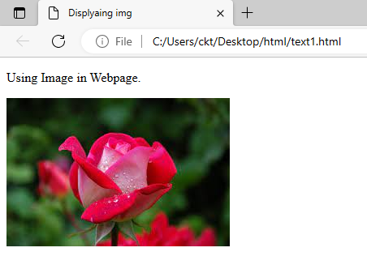

**Program:**

<!DOCtYPE html>

<html>

<head>

<title>image</title>

</head>

<body>

<p>Using Image in Webpage.</p>

<img src="C:\Users\ckt\Downloads\pc.png" alt=”PC” height="200" width="300" align="left">

//<center>

//<img src="C:\Users\ckt\Downloads\pc.png" alt="PC" height="200" width="300" >

//</center>

</body>

</html>

Output:

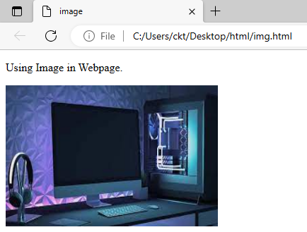

**Program:**

<!DOCtYPE html>

<html>

<head>

<title>image</title>

</head>

<body>

<p>Using Image in Webpage.</p>

<center>

<img src="flower.png" height="400" width="500" usemap=#amap>

<map name="amap">

<area shape="rect" coords="219,48,409,128" alt="flower" href="C:\Users\ckt\Downloads\pc.png">

</center>

</map>

</body>

</html>

**Output:-**

